**Assignment No. 1**

**Aim:** Install Google App Engine. Create hello world app and other simple web applications using python/java.

GAE- a platform-as-a-service product

Google App Engine is mostly used to run Web applications.

offers a secure execution environment in addition to a number of services

Web applications hosted on GAE are sandboxed and run across multiple servers for redundancy and allowing for scaling of resources according to the traffic requirements of the moment

Google provides GAE free up to a certain amount of use for the following resources:

* processor (CPU)
* storage
* application programming interface (API) calls
* concurrent requests

features of GAE include the following:

API selection

Managed infrastructure

Several programming languages

Application diagnostic

Security feature

**Assignment -2**

**Aim :** To use Google App Engine to launch a web application.

 Advantages of Google App Engine:

✓ Infrastructure for Security

✓ Scalability

✓ Performance and Reliability

✓ Cost Savings

✓ Platform Independence

software development kit (SDK)

The App Engine SDK allows you to run Google App Engine Applications on your local computer. It simulates the run-­‐time environment of the Google App Engine infrastructure.

**Assignment 3**

**Aim:**To simulate a cloud scenario using CloudSim and run a scheduling algorithm that is not present in CloudSim.

Cloudsim:

**CloudSim** is an open-source framework, which is used to simulate cloud computing infrastructure and services. It is developed by the CLOUDS Lab organization and is written entirely in Java. It is used for modelling and simulating a cloud computing environment as a means for evaluating a hypothesis prior to software development in order to reproduce tests and results.

For example, if you were to deploy an application or a website on the cloud and wanted to test the services and load that your product can handle and also tune its performance to overcome bottlenecks before risking deployment, then such evaluations could be performed by simply coding a simulation of that environment with the help of various flexible and scalable classes provided by the CloudSim package, free of cost.

Features of CloudSim:

CloudSim provides support for simulation and modelling of:

Large scale virtualized Datacenters, servers and hosts.

Customizable policies for provisioning host to virtual machines.

Energy-aware computational resources.

Application containers and federated clouds (joining and management of multiple public clouds).

Datacenter network topologies and message-passing applications.

Dynamic insertion of simulation entities with stop and resume of simulation.

User-defined allocation and provisioning policies.

**Assignment No. 4**

**Aim:** Find a procedure to transfer the files from one virtual machine to another virtual machine.

Virtual machine:

The virtual machine acts as a bridge to the real environment, hiding the details of operating system

Virtual machine is an application providing a platform independent programming run time that allows applications to execute in the same manner on different platforms

Types of virtualization techniques:

1. Guest Operating system virtualization

● In this virtualization one host operating system is present and in that, virtualization software is installed in that host operating system

2. Shared Kernel Virtualization

This kind of virtualization are also known as the system level or operating system virtualization.

There are two main components of the Linux operating system

1) Kernel 2) root

● Kernel is the one which handles all the important between operating

system and system hardware

● Root file contains all the important libraries and files and utilities which are necessary to run the operating system.

So basically, the host and the guest operating system share the same kernel to communicate with the system hardware, but different root files for their own functioning.

1. Kernel Level Virtualization

● Is this virtualization technique the guest operating system runs its individual kernel unlike the shared kernel virtualization

1. Hypervisor Virtualization

In this virtualization, a program called hypervisor runs directly in the hardware of the CPU which is generally called the ring 0 which is the highest level of privileges provided by the CPU hardware to any software.

1. Paravirtualization

● In this technique, the system calls are made by the kernel of the guest operating system, and those calls are directly handled by the hypervisor and hypervisor, in turn, completes all the tasks.

● The calls between the hypervisor and the guest operating system kernel are called the hypercalls.

2. Full virtualization

In this case, complete control of the guest operating system is given to

the guest operating system.

1. Hardware Virtualization

With the latest CPU coming into the market INTEL and AMD has devised new CPUs that help in providing an extra layer on top of ring 0 which helps the hypervisor to run and take control of the guest operating system.

**Types of virtual machines:**

1. **System Virtual Machine:**

system virtual machine is providing an environment for an OS to be installed completely

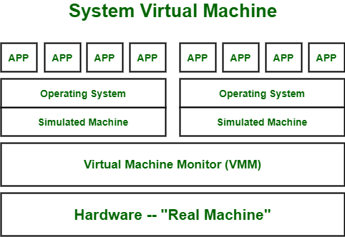

1. **Process Virtual Machine :**

it creates virtual environment of that OS while using some app or program and this environment will be destroyed as soon as we exit from that app.

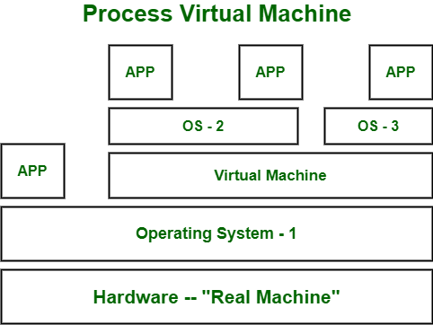

**What is a hypervisor? Types of hypervisors.**

The hypervisor or virtual machine monitor (VMM) is a solution, which creates and manages virtual machines (VMs).The hypervisor is what controls and allocates what portion of hardware resources each operating system should get, in order every one o them to get what they need and not to disrupt each other.

**There are two types of hypervisors:**

●**Type 1 hypervisor:** hypervisors run directly on the system hardware – A “bare metal” embedded hypervisor,

●**Type 2 hypervisor:** hypervisors run on a host operating system that

provides virtualization services, such as I/O device support and memory management.

**Assignment no. 05**

**Aim -** Find a procedure to launch virtual machine using trystack (Online Openstack Demo Version)

A virtual machine (VM) is a digital version of a physical computer. Virtual machine software can run programs and operating systems, store data, connect to networks, and do other computing functions, and requires maintenance such as updates and system monitoring.

## How do Virtual Machine work?

Virtualisation Technology allows you to share a system with many virtual environments. The hypervisor manages the hardware and separates the physical resources from the virtual environments.

AmazonEC2:

Amazon Elastic Compute Cloud (Amazon EC2) provides scalable computing capacity in the Amazon Web Services (AWS) Cloud. Using Amazon EC2 eliminates your need to invest in hardware up front, so you can develop and deploy applications faster. You can use Amazon EC2 to launch as many or as few virtual servers as you need, configure security and networking, and manage storage. Amazon EC2 enables you to scale up or down to handle changes in requirements or spikes in popularity, reducing your need to forecast traffic

OpenStack is a cloud operating system that controls large pools of compute, storage, and networking resources throughout a datacenter, all managed and provisioned through APIs with common authentication mechanisms.

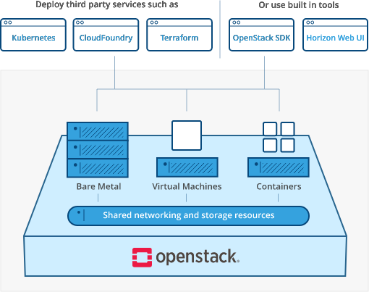

TryStack is a free and easy way for users to try out OpenStack, and set up their own cloud with networking, storage, and computer instances. TryStack is an OpenStack Foundation project; they oversee the political side of it. There are different vendors and companies that have donated resources, such as rack and power and network and servers.

**Assignment No. 6**

**Aim:** Design and deploy a web application in a PaaS environment.

**PAAS(Platform as a service):**

Platform as a Service (PaaS) refers to a cloud computing configuration that helps enterprises operate with an efficient cloud-based strategy. PaaS provides a platform for customers to develop, run, and manage applications without building and maintaining the cloud infrastructure required to develop and launch applications. PaaS permits more efficient application development since the organization can focus on the application itself.

**Examples of PAAS:**

**Google AppEngine:**

**Amazon Amplify:**

**Digital Ocean:**

**Dokku:**

**North-Flank:**

**Heroku:**